MONDAY | 9.30am  -11.00am | Elders Group | Benita or Dawn  9342 0708
 | 3.00pm  - 5.30pm | 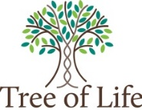  GIRLS  PROGRAM | Sharon Kenney  9342 0708  wadjaknorthside@iinet.net.au
TUESDAY | 10.00am  - 1.30pm | DARDY YORGAS  ART & CRAFT | Debbie  0458 611 938
 | 3.00pm  - 6.00pm |  | Sharon Kenney  9342 0708  BOYS MENTORING  Moorditj Koorlangkas
WEDNESDAY | 9.30am  -2.30pm | 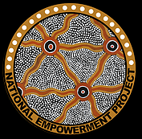  National  Empowerment  Program | Sharon Kenney  9342 0708  wadjaknorthside@iinet.net.au  Dawn  9342 0708
 | 2.30pm  -3.30pm | 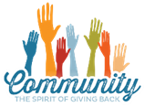  Donations Distribution To Community
 | 3.30pm  -5.00pm | HOMEWORK  CLUB
THURSDAY | 9.30am  -12.30pm | MUMS & BUBS | Dawn  9342 0708
 | 3.00pm  -5.30pm | 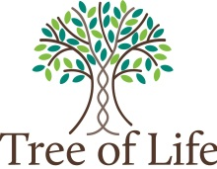  BOYS  PROGRAM | Sharon Kenney  9342 0708  wadjaknorthside@iinet.net.au
FRIDAY | 10.00 am  - 1.00pm | MENS  GROUP | Len Yarran  9342 0708  wadjaknorthside@iinet.net.au  Please check Wadjak Northside Facebook page for details

