“Don’t Keep History a Mystery-
Learn. Share. Grow”

Reconciliation Walk 2018

Join in a short reconciliation walk, with entertainment,
children’s activities & sausage sizzle.

LAKE GWELUP (Huntriss Rd, Karrinyup)
an area of Aboriginal significance
Tuesday 29th May 10am – 1pm
For more information contact Wadjak Northside
on 9342 0708
Schools contact us for competitions
Or email: wadjaknorthside@iinet.net.au
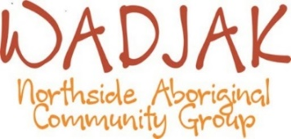
2 Finchley Crescent Balga

